KINGDOM COME: THE WHEN AND HOW
OF MESSIAH’S KINGDOM AND WHY IT MATTERS

PHILIPPE R. STERLING
Pastor, Vista Ridge Bible Fellowship
Lewisville, Texas

I. INTRODUCTION
I live in a town where many of the pastors meet weekly for coffee, reading and discussion of a chapter of the Bible, and prayer. The informal group includes pastors of Lutheran, Presbyterian, Methodist, Baptist, Catholic, Assembly of God, and Independent churches. Every now and then one of the pastors will make a statement that reflects a certain eschatological view. Several often speak of “advancing the kingdom.” Some have made disparaging remarks about “Left Behind” theology and dispensationalists. Such remarks are usually in the context of discussion about the mission of the church and the state of the world. On one occasion I replied to a disparaging remark by stating that I was a dispensationalist and did not think that dispensationalists were the blame for the current state of the church and the world. An apology soon followed with a remark that he did not really subscribe to a particular eschatology. I then replied that everyone has an eschatological view and that view impacts life and ministry. His eschatology appeared to be one of the varieties of postmillennialism which influenced his belief about the mission of the church. He subscribed strongly to Rick Warren’s P.E.A.C.E. Plan to mobilize Christendom and change the world. He has a full-time minister on staff whose responsibility is the implementation of the P.E.A.C.E. Plan for his church.
A believer’s eschatological view matters. What we believe about one aspect of eschatology – the when and how of the coming of the Messianic kingdom– matters. It affects our view of the church and its mission in the world. It affects our view of the Jewish people and the nation of Israel. It affects where we center our hope. This paper will classify and summarize the contemporary evangelical views of the coming of Messiah’s kingdom and point out some of the implications for the church, Israel, and a believer’s hope.
II. EVANGELICAL VIEWS OF MESSIAH’S KINGDOM
The contemporary evangelical views of the kingdom can be classified under three general categories that involve three terms which appear in the literature – already, now, and not yet:

The concept of “already” for the kingdom was introduced with the realized eschatology of C. H. Dodd which set forth that final things have already been realized with the ministry of Christ. Geerhardus Vos, an amillennialist, then utilized the concept of the kingdom as “already” and “not yet” to bring focus on both its present inauguration and future consummation. George Eldon Ladd popularized the two terms for historic/covenant premillennialists. Progressive dispensational premillennialists now employ the two terms to describe the concept of a presently inaugurated kingdom and a future earthly kingdom. Keith A. Mathison, a postmillennialist, adds the term “now” to characterize the concept of the progression of the kingdom in the present age along with “already” and “not yet” for its inauguration and consummation. Stanley Toussaint employs “no, not yet” to characterize his view of a completely future messianic kingdom. The following sections classify the evangelical kingdom views under the headings of “already/now/not yet”, “already/not yet”, and “not yet”.
- ALREADY/NOW/NOT YET VIEWS
- Amillennialism (Present or Realized Millennialism) – Kingdom Inauguration/Continuation/ Consummation

Amillennialism asserts that the kingdom of God is now present in the world. This is the view of many Catholic, Lutheran and Reformed theologians. The kingdom was inaugurated at the first coming of Christ, continues throughout history, and will be consummated at the Second Coming of Christ with the new heaven and the new earth. The Second Coming will be without a millennium. The present age is the realized millennium. Hoekema provides a general description:
. . . the kingdom of God is now present in the world as the victorious Christ is ruling his people by his word and Spirit, though they also look forward to a future, glorious, and perfect kingdom on the new earth in the life to come. Despite the fact that Christ has won a decisive victory over sin and evil, the kingdom of evil will continue to exist alongside of the kingdom of God until the end of the world . . . The amillennialist therefore expects the bringing of the gospel to all nations and the conversion of the fullness of Israel to be completed before Christ’s return. He also looks for an intensified form of tribulation and apostasy as well as the appearance of a personal antichrist before the Second coming.

. . . After the resurrection [general resurrection of believers and unbelievers], believers who are then still alive shall be transformed and glorified. These two groups, raised believers and transformed believers, are then caught up in the clouds to meet the Lord in the air. After this ‘rapture’ of all believers, Christ will complete his descent to earth and conduct the final judgment. After the judgment unbelievers will be consigned to eternal punishment, whereas believers will enjoy forever the blessings of the new heaven and the new earth.

The following chart exhibits some of the elements of the amillennial kingdom view:
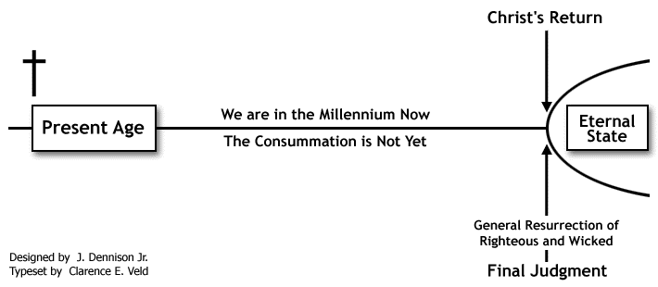
The amillennial kingdom view regards the church as the new Israel. Christ and the church spiritually fulfill in this age the promises made to national Israel.
The amillennial kingdom view embraces a “cultural mandate” for the present kingdom age. The mandate concerns the transformation and redeeming of culture. Christians bring biblical truth to bear upon every area of human culture. The concept is derived from Gen 1:28 where God tells Adam and Eve to fill the earth and subdue it and have dominion.
- Postmillennialism – Kingdom Inauguration/Progression/Consummation
Postmillennialism asserts that the kingdom will be established through the church in this age and then Christ will return. The kingdom was inaugurated at the first coming of Christ, progresses throughout history, and will be consummated by the Second Coming of Christ who will bring in the eternal order. There are presently several versions of postmillennialism which can be classified as revivalist (classic – old and new), reconstructionist, and restorationist.
- Revivalist – Old and New
Keith A. Mathison summarizes the classic postmillennial view:
Like amillennialism, postmillennialism teaches that the “thousand years” of Revelation 20 occurs prior to the Second Coming. Some postmillennialists teach that the millennial age is the entire period of time between Christ’s first and second advents, while others teach that it is the last one thousand years of the present age. According to postmillennialism, in the present age the Holy Spirit will draw unprecedented multitudes to Christ through the faithful preaching of the gospel. Among the multitudes who will be converted are the ethnic Israelites who have thus far rejected the Messiah. At the end of the present age, Christ will return, there will be a general resurrection of the just and the unjust, and the final judgment will take place.

The main difference between postmillennialism and amillennialism is its optimism. The two systems are in general agreement regarding the time of the kingdom. The primary disagreement concerns the nature of this period of time. Amillennialists see a decline in righteousness and suffering for the church before the Second Coming while postmillennialists see the progressive growth of the messianic kingdom and the decline of all other kingdoms. David J. Engelsma observes that reformed amillennialism teaches the church to expect great tribulation before the return of Christ and postmillennialism teaches the saints to expect an earthly victory in the future before the coming of Christ. Oswald Allis comments from the perspective of a postmillennialist: “The most serious error in much of the current ‘prophetic’ teaching of today is the claim that the future of Christendom is to be read not in terms of Revival and Victory, but of growing impotence and apostasy.”
The following chart exhibits some of the elements of classic or revivalist postmillennialism:

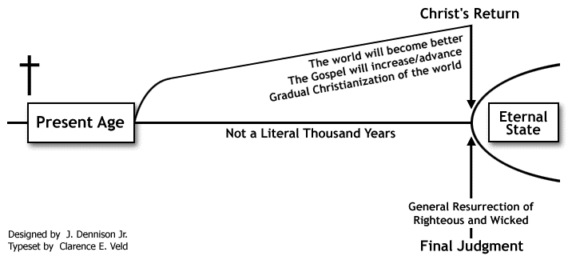

Like amillennialists, postmillennialists regard the church as the new Israel. The church replaces national Israel.
Some postmillennialists intensify the cultural mandate to a dominion mandate. Christians are to influence institutions and power structures so that biblical principles prevail. Two main forms of this can be seen in Reformed reconstructionism and Pentecostal/Charismatic restorationism.
- Reconstructionist – Theonomy
A new form of postmillennialism is Christian reconstructionism and theonomy (the rule of the Law of God). The primary goal is to apply the moral and civil aspects of Old Testament Law to society. The mission of the church goes beyond the spiritual transformation of people to one of reconstructing society and bringing it under the Law of God. This can involve a gradual process of electing Christians to office and changing the laws of the land.
The Coalition on Revival document “The 25 Articles on the Kingdom of God” with the commentary by Jay Grimstead reflects aspects of this view. Grimstead presents the following chart to illustrate what the Coalition on Revival does not want and what it does want in our current system of government:
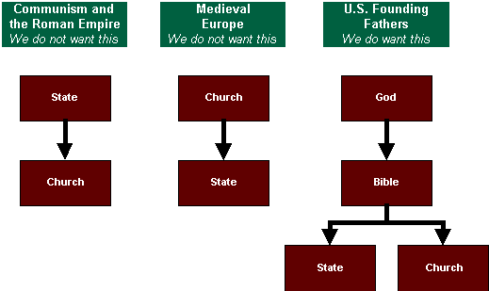
- Restorationist – Dominion or Kingdom Now
Another form of postmillennialism has developed in some Pentecostal and Charismatic circles. C. Peter Wagner recently described the movement in Dominion! How Kingdom Action Can Change the World. He writes in the introduction:
I am writing Dominion! To help provide a biblical, theological and strategic foundation to undergird the urgent mandate for the Church to actively engage in transforming society. This is a relatively new paradigm for most of us, both in the nuclear Church and in the extended Church of the workplace, so I will pull together many important threads such as the biblical government of the Church (apostles and prophets), dominion or Kingdom theology, an open view of God, the principles and practices of spiritual warfare, the Church in the workplace, the great transfer of wealth and other themes. These all point toward the book’s subtitle: “How Kingdom Action Can Change the World.”

Wagner uses the term “cultural mandate” several times. He explains, “By it I mean, simply, that we have an assignment from God to take dominion and transform society.” He rejects the “pre-trib, pre-mil” view of the end times for a “victorious eschatology”. He quotes from the book Victorious Eschatology by Harold Eberle and Martin Trench, “Before Jesus returns, the Church will rise in glory, unity, and maturity. The Kingdom of God will grow and advance until it fills the Earth.” Victorious eschatology argues for a Partial Preterist view of eschatology (the biblical prophecies concerning the last days were literally fulfilled at the time of the destruction of Jerusalem in 70 A.D.) with which Wagner states he personally identifies.
According to Wagner the goal of transforming society and establishing God’s kingdom on earth will be achieved through three phases: phase one involves social action much like Rick Warren’s P.E.A.C.E. Plan and the social and spiritual gospel of the Lausanne movement, phase two goes on to strategic-level-spiritual warfare, and phase three involves such things as apostolic/prophetic government of the Church, dominion theology, and the 7 – Mountain mandate. The blessings of this establishment of the kingdom of God can be the elimination of sickness and systemic poverty. The following chart exhibits some elements of this view of the kingdom of God:
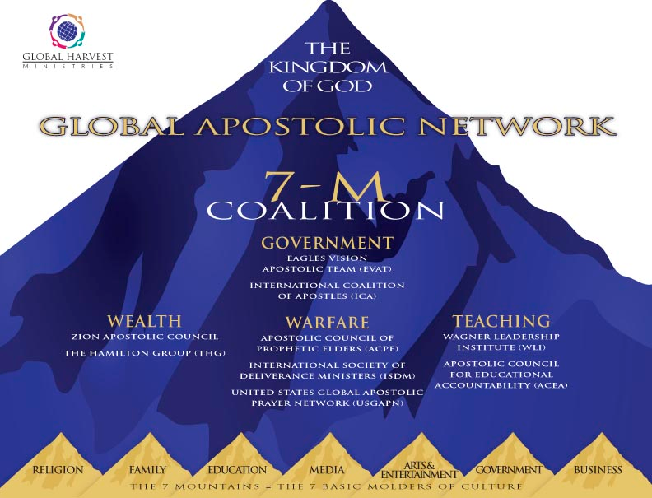
Many associated with this kingdom view helped to set up the “Response” prayer event in Houston last August hosted by Governor Rick Perry. Other “Response” events are planned for 2012. Responding to press criticism concerning the New Apostolic Reformation’s involvement in the event and use of the term “dominion”, Wagner wrote in Charisma:
The way to achieve dominion is not to become “America’s Taliban,” but to have kingdom minded people in every one of society’s “seven mountains” – Religion, Family, Education, Media, Arts and Entertainment, and Business – so they can use their influence to create an environment in which the blessings and prosperity of the kingdom of God can permeate all areas of society.

- ALREADY/NOT YET VIEWS
Two views within the premillennial system of eschatology make use of “already, not yet” terminology in reference to the kingdom: historic/covenant premillennialism and progressive dispensational premillennialism. Premillennialism asserts that there will be a literal kingdom of Christ on earth after the Second Coming.
- Historic/Covenant Premillennialism – Kingdom Inauguration/Consummation
George Eldon Ladd published a number of influential works within the historic/covenant premillennial view of the kingdom. The kingdom is both present and future. The kingdom is “already” and “not yet”. The kingdom was inaugurated at the first coming of Christ and is present spiritually during the church age. The resurrection and rapture of the church will take place at the end of the tribulation at the Second Coming of Christ. The kingdom will be consummated with the millennial reign of Christ on earth. The following chart exhibits some of the elements of historic/covenant premillennialism:
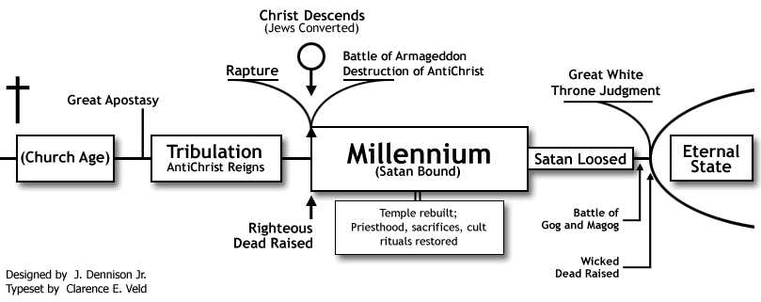
The church is spiritual Israel in this age. Though there will be a future role for Israel in the millennial kingdom.
The view that the church now replaces Israel can affect one’s view of Jewish and Christian Zionism. A young man who was completing an advanced theological degree from a European school started attending the church I pastor. On our first visit over coffee he mentioned to me that he was a historic premillennialist. Over the year that he came he periodically made very negative comments about the nation of Israel and very supportive comments of the Palestinian cause.
If there is a present aspect of the Messianic kingdom today, then it affects the mission of the church. It provides greater support for the view that the church has both a cultural and spiritual mandate in this age, a social and evangelistic mission.
- Progressive Dispensational Premillennialism – Kingdom Inauguration/Fulfillment
Progressive dispensationalists teach that the kingdom is both present and future. Robert Saucy writes that they present a mediating position between non-dispensationalism and traditional dispensationalism. Darrell Bock sets forth the duality of kingdom inauguration and kingdom fulfillment:
The kingdom theme reveals the stages of Jesus’ rule….First, there is the inauguration with Jesus’ coming….In the initial phase, one can speak of the “already,” the “sneak preview,” or the invisible “kingdom rule of Jesus”….The new covenant is inaugurated, but not totally consummated. Jesus’ rule from God’s right hand initially yet decisively fulfills promises made to David….Those who believe now are a picture of what will appear in greater form in the consummation….[The church] is a sneak preview of what is to come….The church is the current phase of the kingdom…The church’s call and mission is to be a light and point the way to God both in its message and in the caring activity of its daily life…Confusion about the identity of the kingdom, its subjects, and its nature leads to confusion about the church’s mission and mandate…In the second stage, the promise moves to ultimate consummation….two stage program of kingdom-covenant fulfillment.

David L. Turner describes the kingdom in terms of three phases: “a preliminary and anticipatory stage brought to earth by the first coming of Christ [a bronze age], an intermediate silver age brought to earth at Christ’s second coming, and an ultimate, golden age, consummated when all opposition to God’s rule has ceased.” Those who now believe are “an earthly colony of the coming heavenly city, the new Jerusalem.”
Craig Blaising portrays in a chart the kingdom view of progressive dispensationalism:
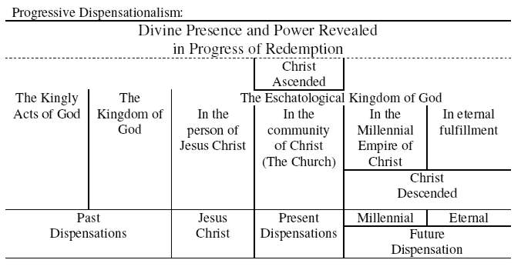
- NOT YET VIEWS
A form of premillennialism is dispensationalism. Like historic/covenant premillennialists, it holds that Christ will return to earth to reign over a millennial kingdom. It also teaches that Christ will return at a time of tribulation. However, unlike historic/covenant premillennialists, many dispensationalists hold to a pretribulational rapture of the church. The following chart exhibits some of the elements of dispensational premillennialism:
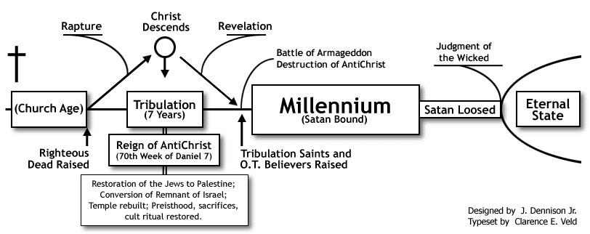
Diversity exists within dispensationalism. The greatest differences lie between progressive dispensationalists and classical and revised dispensationalists. Progressives see an inaugurated form of the kingdom in the present age that involves a partial fulfillment of the new covenant and the Davidic covenant. Progressive dispensational premillennialism fits under the category of “already, not yet”. Classical and revised dispensational premillennialism fit under the category of “not yet”. For these two types of dispensational premillennialism the establishment of the Davidic messianic kingdom is completely in the future after the Second Coming of Christ. There are differences among the classical and revised dispensationalists. Craig Blaising sets forth concise descriptions of these two types and the differences within the types. We will focus on their slightly differing kingdom views
- Revised (Modified, Normative) Dispensational Premillennialism – Kingdom Anticipation
Blaising takes the title “revised dispensationalism” from the revision of the Scofield Reference Bible of 1967. Revised dispensationalism is a modification of classical dispensationalism introduced by the dispensationalists of the 1950s and ‘60s. Perhaps the most important revision, says Blaising, was the abandonment of the eternal dualism of heavenly and earthly peoples.
- Pentecost
J. Dwight Pentecost uses the term “eternal kingdom” to refer to God’s rule over all He has made and the term “theocratic kingdom” to refer to His mediated rule on earth. The theocratic mediated kingdom unfolds in ten successive stages from Creation to the Millennium. The church is an aspect of the present theocratic kingdom. The Davidic/Messianic kingdom comprises the future theocratic kingdom established at the Second Coming of Christ. The kingdom continues in an earthly form in the eternal state. Blaising portrays in a chart the kingdom view of Pentecost:
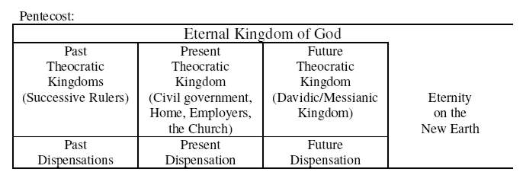
- Ryrie
Charles Ryrie employs the term “universal kingdom” for God’s rule over all things. The Davidic kingdom appeared in the old dispensation and has been in abeyance since the Exile. Jesus began a threefold kingdom program: first, Jesus offered the kingdom to Israel but was rejected; next is the mystery form of the kingdom which is Christendom; next is the Davidic millennial kingdom to be followed by eternity under the universal kingdom of God. There is also a present “spiritual kingdom” of Christ’s rule over believers today. Blaising portrays in a chart the kingdom view of Ryrie:
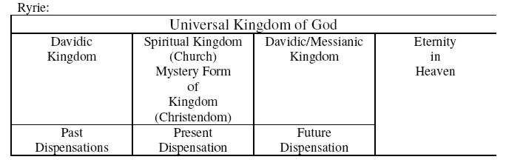
Ryrie addresses the issue of the Christian and social responsibility. He finds no evidence in the Scriptures that the church is called to solve the social ills of the world. Christians are to proclaim the gospel and do good works but are not under a mandate of social action. He argues that the social agenda of many evangelicals does not have a basis in the New Testament.
- Walvoord
John Walvoord uses the terms “universal kingdom” for God’s rule over all He has made and “spiritual kingdom” for God’s rule over the saved in all ages. The Davidic kingdom was God’s theocratic rule through David and a Davidic descendant. Jesus offered the Davidic kingdom to Israel but it was postponed when they rejected Him. The Davidic kingdom will be realized in Christ’s millennial reign on earth. There is a present mystery form of the kingdom which is the spiritual rule of Christ in the church. At the close of the millennium the Davidic kingdom will come to an end and the universal and spiritual kingdoms will be united forever. Blaising portrays Walvoord’s view in the following chart:
- McClain/Toussaint
Alva J. McClain introduced the terms “universal kingdom” and “mediatorial kingdom”. The universal kingdom is God’s rule over all things. The mediatorial kingdom is God’s rule over the earth through a divinely chosen mediator. A succession of mediators began with Abraham and continued on through the kings of Israel. Jesus is the Davidic heir and the mediator of the messianic kingdom. Since Jesus is not now on the earth there is no present mediatorial kingdom. The present age is an “Interregnum”, a period between the reigns. Jesus will establish the mediatorial kingdom again on earth at the Second Coming. The mediatorial kingdom will merge with the universal kingdom at the close of the Millennium. Blaising portrays McClain’s view in the following chart:
Toussaint agrees with McClain that there’s not a present mediatorial kingdom. Passages in the New Testament that speak of the presence of the kingdom refer to the future kingdom.
- Classical Dispensational Premillennialism – Kingdom Anticipation
Blaising uses the phrase “classical dispensationalism” to refer to the dispensational views stemming from the writings of John Nelson Darby in the mid-nineteenth century, the Scofield Reference Bible in 1909 and 1917, and the Systematic Theology of Lewis Sperry Chafer in 1948. He notes that what marks classical dispensationalism is the belief that Scripture reveals a heavenly purpose for a heavenly people (the church) and an earthly purpose for an earthly people (Israel and the Gentile nations). Blaising provides an extended discussion of this distinction:
Perhaps the most important feature of classical dispensationalism is its dualistic idea of redemption. In order to understand the Bible, one needed to recognize that God was pursuing two different purposes, one related to heaven and one related to the earth. These two purposes affected God’s dealings with humanity. In fact, they resulted in an anthropological dualism: a heavenly humanity and an earthly humanity.

To put it another way, one of God’s purposes in redemption was to release the earth from the curse of corruption and decay, and to restore upon it a humanity free from death and sin. This was the earthly purpose of God. God will restore permanently the paradise lost in the Fall, granting immortality to earthly humanity. Some writers envisioned these blessings in quite physical terms, including human reproduction to increase the plenitude of the human race.

It is important to understand that in classical dispensationalism this earthly humanity is eternal. It first appears in the Millennium (the future 1,000-year reign of Christ), but it will not have reached its eternal glory until the end of that time. It will then continue onto the new earth populating it forever.

But God has a second purpose, a heavenly purpose which envisions a heavenly humanity. This heavenly humanity was to be made up of all the redeemed from all dispensations who would be resurrected from the dead. Whereas the earthly humanity concerned people who had not died but who were preserved by God from death, the heavenly humanity was made up of all the saved who had died, whom God would resurrect from the dead.

By the nature of the case, the heavenly humanity would be a “transdispensational” community. All the saved of previous dispensations are dead, and all those of the present dispensation prior to this generation are likewise dead. They are, of course, with the Lord now. But their future hope lies in the resurrection, by which they will fully receive their heavenly salvation in a heavenly inheritance.

The earthly humanity will begin with that generation of the saved who are present on earth at the Lord’s return. They will be preserved from death, as will all their descendants who are of faith. They will not be resurrected from the dead nor will they be transformed into a resurrection mode of life. They are earthly people and they experience the earthly salvation which God has designed according to His purpose for the earth.

In summary, the central dualism of classical dispensationalism asserts that God is pursuing two purposes in redemption, one relating to heaven and a heavenly people and one relating to the earth concerning an earthly people. Both purposes will be accomplished and confirmed forever.

Blaising notes later concerning the different stance of progressive dispensationalists:
One of the striking differences between progressives and earlier dispensationalists, is that progressives do not view the church as an anthropological category in the same class as terms like Israel, Gentile Nations, Jews, and Gentile people. The church is neither a separate race of humanity (in contrast to Jews and Gentiles) nor a competing nation (alongside Israel and Gentile nations), nor is it a group of angelic-like humans destined for the heavens in contrast to the rest of redeemed humanity on the earth. The church is precisely redeemed humanity itself (both Jews and Gentiles) as it exists in this dispensation prior to the coming of Christ.

Blaising portrays the purposes of God in classical dispensationalism in the following chart:
Classical dispensationalists see the church age as a parenthesis in God’s kingdom program with Israel. Most also hold that the church should be primarily concerned with spiritual issues in the present age instead of political and social issues.
III. IMPLICATIONS OF MESSIAH’S KINGDOM VIEWS
What are the implications of the contemporary evangelical views of the coming of the kingdom for the church, Israel, and a believer’s hope? What we believe about the when and how of the coming of the kingdom affects our view of the church and its mission in the world, our view of the Jewish people and the nation of Israel, and our view of the Christian hope.
- THE CHURCH AND ITS MISSION
Darrell Bock provides a good summary of how the differences in kingdom view can practically impact mission and outreach. For postmillennialism the church’s call and destiny involves the declaration and establishment of the Lord’s sovereignty over all the social-political-religious structures on earth. The church’s mission moves towards victory and authority in every sphere of human life. The church has a full-blown cultural mandate to achieve her call in all areas of life. Theonomic postmillennialism expresses it the most comprehensively with the goal of establishing the Old Testament law.
Amillennialism with its view of the depravity of humankind in the world has a less triumphant view than postmillennialism. The church faithfully witnesses to the grace of God in every sphere of life, but victory is something that will come in the Lord’s sovereign timing. The church will not bring it itself. The church as a light in the world balances a spiritual and social/cultural mission.
Premillennialism splits into two types of expressions concerning the church’s mission. Some premillennialists concentrate the church’s mission on the spiritual dimension since social-political redemption comes with the establishment of the Messianic kingdom in the age to come. The church now gives primary attention to evangelism and discipleship. Humanitarian outreach can serve an evangelistic goal through such efforts as medical missions, relief work, gospel missions for the homeless, and so on. The church does not focus its mission on changing social-political structures. Classical and revised dispensationalists tend to fall in this expression.
Other premillennialists understand the call of the church is to show the world how a redeeming perspective impacts relationships at every social, political, and religious level. The church reflects this in the way she functions internally and in how she serves, engages and critiques the world. This outlook is similar to that of the amillennialist in that the church does not bring about the victory but reflects the “wholeness” of salvation in interaction with the larger culture. Historic/covenant premillennialists and progressives dispensationalists tend to fall in this expression.
Tony Evans provides a “covenantal and progressive dispensationalist” model for a kingdom agenda. He writes that “It is time for Christians to set forth a kingdom agenda!” Such an agenda should be big enough to include both individual and societal structures. He provides this definition: “The kingdom agenda, then, may be defined as the visible demonstration of the comprehensive rule of God over every area of life.” He explains: “In this age, the church is the primary manifestation of the kingdom, and it is the primary means by which God is extending His kingdom rule in this world.” The church manifests the kingdom’s presence. As such “it is crucial for the church to function as the epicenter of community life.” He exclaims: “God wants the world to see the previews of His coming attraction.”
- ISRAEL
The matter of the future of the land and people of Israel is a point of disagreement among the kingdom views. Some see a national, political future for Israel and some don’t.
Classical and revised dispensationalists teach that there is a clear distinction between Israel and the church and that there is a place for both in God’s future plans. Progressives see more continuity between Israel and the church but still preserve key distinctions. Dispensationalists of all types tend to be supportive of the modern state of Israel.
Amillennialists and postmillennialists understand that the church is spiritual Israel and that ethnic Israel has forfeited the land and national promises of God in the Old Testament. The church has replaced or superseded Israel in God’s future plans. The modern nation of Israel has no more significance in God’s kingdom plan than any other nation. Some current evangelical authors are openly anti-Israel. Mitch Glaser of Chosen People Ministries has recently written that he is greatly concerned “that the Church is becoming so pro-Palestinian that it is turning anti-Israel!”
- A BELIEVER’S HOPE
A believer’s view of the kingdom affects the content of his hope. Does he center his hope on this world becoming a better place or does he center his hope on the coming of the Messiah and the reward he will receive in His kingdom for his faithfulness in this age? The amillennial hope is that of a presently realized kingdom that struggles with evil until the Second Coming and the beginning of the eternal state. The postmillennial hope is that of the church establishing the kingdom prior to the return of the Messiah. The premillennial hope splits into two types. The first type flows from the “already/not yet” view of the kingdom which gives the church a greater responsibility to affect the social/political structures of this world and directs hope a little more to the matters of this age. The second flows from the “not yet” view of the kingdom which tends to emphasize to a greater degree the spiritual mission of the church over a social/cultural mission and directs hope a little more to the coming age.
IV. CONCLUSION
What we believe about the when and the how of the Messianic kingdom matters since it affects our view of the mission of the church, our view of God’s plan for ethnic and national Israel, and the content of our hope. Depending on our kingdom view we may have the church undertake a greater or lesser role in transforming social and political structures. Depending on our kingdom view we may express a greater or lesser support for the nation of Israel. Depending on our kingdom view we may have a hope that is centered to a greater or lesser extent on this present world or on the coming Messianic age. Our view of the kingdom matters.
One of the main issues that Joseph C. Dillow addresses in the book The Reign of the Servant Kings is the final significance of man. That significance is the fulfillment of the hope of becoming partakers with David’s Greater Son in His kingdom reign. Dillow concludes, “That great future must constantly be set before the vision of all who name the Lord Jesus as their King. We should daily be evaluating our lives, our priorities, and our hearts in view of how we will feel about our decisions ten thousand years from now.”

See Charles Harold Dodd, The Parables of the Kingdom (London: Nisbet, 1935).
See Geerhardus Vos, The Pauline Eschatology (Princeton University Press, 1930); Biblical Theology: Old and New Testaments (Grand Rapids, Michigan: Wm. B. Eerdmans), 407.
See George Eldon Ladd, The Presence of the Future (Grand Rapids: Eerdmans, 1974); The Gospel of the Kingdom (Grand Rapids: Eerdmans, 1959).
See Craig A. Blaising and Darrell Bock, Progressive Dispensationalism (Grand Rapids, Michigan: Baker Books, 1993, 2000 paperback edition), 97-98.
See Keith A. Mathison, Postmillennialism: An Eschatology of Hope (Phillipsberg, New Jersey: P & R Publishing Company, 1999):167-168.
Stanley D. Tousaint and Jay A. Quine, “No, Not Yet: The Contingency of God’s Promised Kingdom” Bibliotheca Sacra 164 (April-June 2007), 131-47.
Two amillennial works are Anthony A. Hoekema, The Bible and the Future (Grand Rapids: William B. Eerdmans,1979) and Kim Riddlebarger, A Case for Amillennialism (Grand Rapids: Baker Books, 2003).
Hoekema, 174.
The chart can be found at http://www.blueletterbible.org/faq/nunc.html, accessed December 19, 2011.
Riddlebarger, 117-123.
See Rex M. Rogers, Christian Liberty, (Baker Books, 2003):67-68. Rogers summarizes the various eschatological views and concludes that they help determine the understanding of the cultural mandate. Premillennialism is generally not optimistic about the transformation of society. Postmillennialism and amillennialism embrace it. See also Nancy Pearcy, Total Truth (Wheaton: Crossway, 2004),17.
See Postmillennialism: An Eschatology of Hope; Kenneth L Gentry, Jr, “Postmillennialism,” Three Views on the Millennium and Beyond, Gen. Ed. Darrell L. Bock (Grand Rapids: Zondervan Publishing House, 1999).
Postmillenialism: An Eschatology of Hope, 10.
Ibid., 179-185.
Ibid., 191.
David J. Engelsma, Christ’s Spiritual Kingdom: A Defense of Reformed Amillennialism (The Reformed Witness, 2001), 51, 69.
Oswald T. Allis, “foreword” to Roderick Campbell, Israel and the New Covenant (Philadelphia: Presbyterian and Reformed, 1954), ix.
This chart can be found at http://www.blueletterbible.org/faq/post.html, accessed December 19, 2011.
Some primary reconstructionists works are: Rousas J. Rushdoony, The Institutes of Biblical Law (Craig Press, 1973); Gary North and Gary DeMar, Christian Reconstructionism: What It Is, What It Isn’t (Tyler, Tex: Institute for Christian Economics, 1991); Greg Bahnsen, Theonomy in Christian Ethics (Craig Press, 1979). For a critique from a dispensational viewpoint see Thomas D. Ice, “An Evaluation of Theonomic Neopostmillennialism”, Bibliotheca Sacra, July-September 1988, 281-300.
The document can be found at http://65.175.91.69/Reformation_net/Pages/Kingdom_of_God_Commentary.htm, accessed December 20, 2011.
C. Peter Wagner, Dominion! How Kingdom Action Can Change the World (Grand Rapids, Michigan: Chosen Books, 2008),11.
Ibid., 46.
Ibid., 61.
Ibid., 62.
Ibid., 157-179.
The chart can be found at http://livingjourney.files.wordpress.com/2007/12/7m.jpg, accessed December 20, 2011.
See http://theresponseusa.com/, accessed December 20, 2011.
C. Peter Wagner, “The Truth about the New Apostolic Reformation”, Charisma, Nov 2011, 40-44.
See Donald K. Campbell and Jeffrey L. Townsend, A Case for Premillennialism: A New Consensus (Chicago: The Moody Press, 1992).
For example, The Gospel of the Kingdom (Grand Rapids: William B. Eerdmans Publishing Company, 1959); A Theology of the New Testament (Grand Rapids: William B. Eerdmans Publishing Company, 1974).
The chart can be found at http://www.blueletterbible.org/faq/hispre.html, accessed December 20, 2011.
Major works include Dispensationalism, Israel and the Church, Craig A. Blaising and Darrell L. Bock, Editors (Zondervan Publishing House, 1992); Robert L. Saucy, The Case for Progressive Dispensationalism (Zondervan Publishing House, 1993); Craig A. Blaising and Darrell L. Bock, Progressive Dispensationalism (Grand Rapids, Michigan: Baker Books, 1993). Some in the free grace movement such as J. Paul Tanner are Progressive Dispensationalists – see paultanner.org, “A Progressive Fulfillment View of Israel’s Old Testament Covenants and Promises.”
Saucy, 27.
Darrell L. Bock, “The Reign of the Lord Christ,” in Dispensationalism, Israel and the Church, 65-66.
David L. Turner, “The New Jerusalem in Revelation 21:1-22: Consummation of a Biblical Continuum”, in Dispensationalism, Israel and the Church, 290-291.
Ibid., 291.
Progressive Dispensationalism, 55. This chart and the following ones for Pentecost and Ryrie are slightly modified versions by Chris Barney found at http://20.sharperiron.org/showthread.php?t=941, accessed December 21, 2011.
The chart can be found at http://www.blueletterbible.org/faq/dispre.html, accessed December 21, 2011.
Craig A. Blaising, “The Extent and Varieties of Dispensationalism”, in Progressive Dispensationalism; see also"Changing Patterns in American Dispensational Theology", Wesleyan Theological Journal 29, 149–64.
See “Changing Patterns in American Dispensational Theology”. Ryrie prefers the designation of normative or traditional dispensationalism (Dispensationalism, 79)
Progressive Dispensationalism, 31. See the following section on Classical Dispensational Premillennialism.
See J. Dwight Pentecost, Thy Kingdom Come (Wheaton: Victor Books, 1990).
Progressive Dispensationalism, 44.
See Charles C. Ryrie, Dispensationalism (Chicago: Moody Publishers, 1995, 2007).
Progressive Dispensationalism, 42.
See Charles C. Ryrie, What You Should Know about Social Responsibility (Chicago: Moody Press, 1982).
See John Walvoord, Major Bible Prophecies (Grand Rapids; Zondervan, 1991).
Progressive Dispensationalism, 44.
See Alva J. McClain, The Greatness of the Kingdom (Winona Lake, Indiana: BMH Books, 2007 Printing of 1959 edition).
Progressive Dispensationalism, 40.
See Stanley D. Toussaint, Behold the King (Portland: Multnomah, 1980). Also “No, Not Yet: The Contingency of God’s Promised Kingdom.”
See “Changing Patterns in American Dispensational Theology”.
See, for example, Lewis Sperry Chafer, Systematic Theology (Dallas Seminary Press, 1948), 4:401, 415-419. Frank D. Carmical, The Omega Reunion (Dallas: Redencion Viva, 1986), appears to reflect one form of the classical dispensational view of an earthly people and a heavenly people in a fictional work. Bob Bryant pastor of Cypress Valley Bible Church in Marshall, Texas, presented a paper with a similar view at the 2009 Grace Evangelical Society Conference: “The Unique, Eternal Role of Resurrected People.” See also comments on Revelation 21:24 by Robert Vacendak, “Revelation” in The Grace New Testament Commentary (Denton, TX: Grace Evangelical Society, 2010), 1330.
Progressive Dispensationalism, 23-24.
Blaising does not name or quote adherents of this view. Two are J. A. Seiss and Clarence Larkin. Larkin wrote, “Shall not God then during the “renovation of the Earth by Fire,” in some manner, not as yet revealed, take off righteous representatives of the Millennial nations that he purposes to save, and when the earth is again fit to be the abode of men, place them back on the New Earth, that they may increase and multiply and replenish it, as Adam (Gen. 1:27-28), and Noah (Gen. 9:1), were told to multiply and replenish the present earth….When this Earth shall have gone through its “baptism of Fire,” and shall be again fit for the occupancy of man, the representatives of the “Saved Nations” (Rev. 21:24) will be men and women in whom no taint of sin will remain, and who cannot therefore impart it to their offspring, who will be like the offspring of Adam and Eve would have been if they had not sinned.”—Clarence Larkin, The Book of Revelation (Published 1919 by C. Larkin), 206, 207. Seiss wrote, “I therefore hold it to be a necessary and integral part of the Scriptural doctrine of human redemption, that our race, as a self-multiplying order of beings, will never cease either to exist or to possess the earth….Ransomed nations in the flesh are therefore among the occupants of the new earth, and the blessed and happy dwellers in it, as Adam and Eve dwelt in Paradise.”—J. A. Seiss, The Apocalypse: Lectures on the Book of Revelation (Grand Rapids, MI: Zondervan Publishing House, 1900, 1977), 483, 492. John Walvoord, a revised dispensationalist, rejects this view. He wrote, “Larkin introduces the startling point of view that children will be born in the eternal state who unlike the posterity of Adam and Eve will be sinless. There is no indication whatever in Scripture that resurrected and translated being have the quality of human sex, much less the capacity to produce offspring.”—John F. Walvoord, The Revelation of Jesus Christ (Chicago, IL: Moody Press, 1966), 327. Larkin did not say, as Walvoord implies, that resurrected and translated beings produced offspring; he said representatives of the Millennial nations do so. Jerome Smith clarifies, “There are two classes of people who will live eternally upon the earth: (1) the saints, who as co-heirs with Christ (Rom. 8:17) are given glorified bodies (1 Cor. 15:52), who possess the kingdom (Dan. 7:18) and rule over the kingdom (Rev. 20:4, 6) as its inheritors (Matt. 25:34); (2) natural people, described here [1 Cor. 15:52] as “flesh and blood” who are the eternal subjects of the kingdom, who eternally perpetuate the natural race of earthly men in the flesh.”—Jerome Smith, The New Treasury of Scripture Knowledge (Nashville, TN: Thomas Nelson Publishers, 1992), “1 Cor 15:50”, 1349. Robert Thomas concurs, “In fact, this is an issue on which the text of Revelation is silent, but there is one further theory which seems to satisfy the available criteria best. (10)This opinion holds that ‘the nations’ are composed of saved people who survive the millennial kingdom without dying and without joining Satan’s rebellion and who undergo some sort of transformation that suits them for life in the eternal state. They will be like Adam and Eve in the Garden of Eden prior to the fall (cf. Govett, Seiss). They will be unresurrected human beings who will inhabit the new earth, Paradise restored (Rev. 22:1-5), throughout eternity. These will be the ones over whom God’s resurrected saints will reign (22:5). Nations, peoples and men on earth must continue in the flesh as Adam and Eve did before the fall (Seiss).” – Robert L. Thomas, Revelation 8-22 (Chicago, Il: Moody Press, 1995), 478. Herman Hoyt, president of Grace College and Theological Seminary from 1962 to 1976 strongly argued for this view – See Herman A. Hoyt, The End Times (Chicago: Moody Press, 1969), 229-233. F. S. Elmore links Hoyt with Darby, “Hoyt agreed with Darby that there would be saints living in their natural state forever, thus allowing for two modes of life in the eternal state.” – F. S. Elmore, “A critical Examination of the Doctrine of the Two Peoples of God in John Nelson Darby” (Th.D. diss., Dallas Theological Seminary, 1990), 305. Two older writers who advanced this view are Robert Govett, Govett on Revelation (Conley & Schoettle Publishing Co., 1981, formerly published in London, England, 1861, under the title, THE APOCALYPSE: Expounded by Scripture, under the pseudonym Matheetees), IV 472, 475 and E. W. Bullinger, The Apocalypse (Samuel, Bogsten & Sons LTD, Reprinted 1972), 668. See note 53 for some contemporary free grace adherents of this view. The two main arguments advanced for the view are (1) the distinction is suggested by Scripture, and (2) the distinction is suggested theologically by the ultimate fulfillment of God’s original creative purpose.
Progressive Dispensationalism, 27.
Ibid., 25.
See his “Summary Essay” in Three Views on the Millennium and Beyond, 306-307. See also Craig Blaising’s discussion in Progressive Dispensationalism, 285-290.
For a contrast of the postmillennial and premillennial view of law and government see Norman L. Geisler, “A Premillennial View of Law and Government” Bibliotheca Sacra (July-September 1985: 250-266).
Michael Pocock comments, “the principal task of believers is to preach the gospel, teach new believers to obey all the commands of Christ (Matt. 28:19-20), and participate fully in the formation and life of the body of Christ, His church…They are to ‘do good to all men…They are to obey and seek the good of governments and rulers…But believers in the present age will not attempt the overthrow of unjust governments or societies, or establish new ones as a church or as a part of its mission.” Michael Pocock, “The Destiny of the World and the Work of Missions” Bibliotheca Sacra (October-December 1988), 446. Kevin De Young and Greg Gilbert in their recent book What Is the Mission of the Church? concur, “We believe the church is sent into the world to witness to Jesus by proclaiming the gospel and making disciples of all nations. This is our task. This is our unique and central calling” (Wheaton: Crossway, 2011), 26.
Tony Evans, The kingdom Agenda (Chicago: Moody Publishers, 1999, 2006), 12.
Ibid.
Ibid., 27.
Ibid., 275.
Ibid., 286.
Ibid., 288.
H. Wayne House provides a summary of the major positions held today in “The Future of National Israel” Bibliotheca Sacra 166 (October-December 2009), 463-81. See also Walter C. Kaiser, Jr., “An Evangelical Response” in Dispensationalism, Israel and the Church, 360-376. Kaiser sees five different methods for relating Israel and the church over the course of the Christian centuries which he labels as: the replacement covenant – church has replaced Israel; the super covenant – Israel and the church are one and the same throughout history; the dual covenant – Jewish people are saved through the promise God left Abraham and do not need the gospel offered to the Gentiles which is a separate covenant; the separate covenant – Israel and the church have separate identities, promises and destinies; and the renewed covenant – there is one people with a number of discernable aspects within that one people such as Israel and the church (continuity and enlargement).
Mitch Glaser, President’s Prayer Letter (Chosen People Ministries, December 2011).
Joseph C. Dillow, The Reign of the Servant Kings (Hayesville, NC: Schoettle Publishing Co., 2006, Third Printing), 605.

